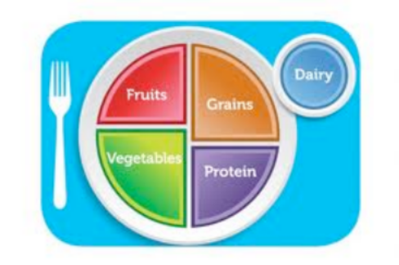

What’s Up In Our Cafeteria

1. Look around. What are most students eating for lunch?

Do you think this is a good choice? Why or why not?

What could be added or adjusted to make their lunch more balanced(Think about what food groups are missing from their plate)?

- What are most kids drinking with their lunch?

Do you think this is a healthy choice? Why or why not?

- Look at each of the food stations. Is it possible to balance your food plate at each station?
Sandwich:

Pasta:

Asian:

Salad Bar:

Western:

Vegetarian:

Pizza:

Coffee Bar:

Do you think healthy food choices are easily accessible in the cafeteria?

If you were to advocate for one healthy change/addition in the cafeteria, what would it be?

